**实验报告八 直流电机PID调速-旋钮控制目标速度**

|  |  |  |  |
| --- | --- | --- | --- |
|  |  |  |  |
|  |  |  |  |
|  |  |  |  |
|  |  |  |  |

1. 电路图

如图进行电路链接。

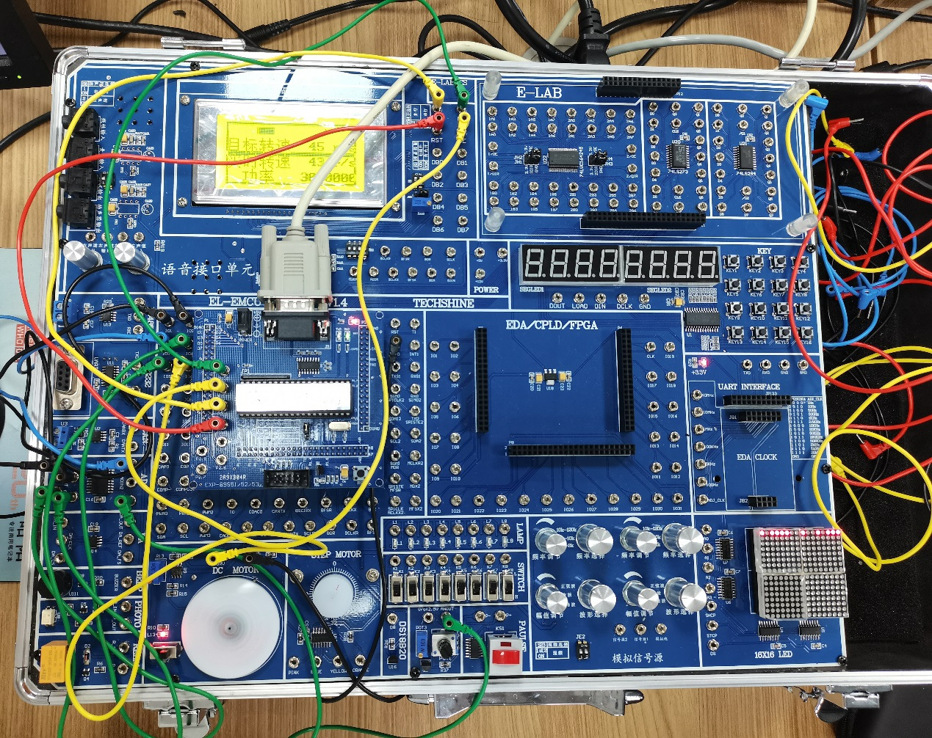

1. 程序分析

1、流程图的形式给出程序设计的思路，

2、代码及必要注释。

#include <reg51.h>

#include <intrins.h>

#include <stdio.h>

#include "st7920.h"

#include "tlc2543.h"

#include "delay.h"

#include "math.h"

#define MAX_N 30000 // 最大累加值, 即最大占空比

#define MAX_SPEED 180 // 最大转速, 单位 r/s, 测试得到

#define TICK_TIME_US 100 // 每个tick周期 = 100us

#define TICK_PER_MS (1000/TICK_TIME_US) // 每毫秒的tick数

#define TIMER_PRESET_VALUE TICK_TIME_US // 定时器的预设值, 设为此值 = 100us 时，定时器每tick中断一次

int targetSpeed; // 目标转速

int motorSpeed; // 实时转速

unsigned int motorN = 0; // 越大转越快

sbit motorDrive = P0^5; // 电机驱动引脚

sbit key1 = P2^4;

sbit key2 = P2^5;

sbit key3 = P2^6;

// 绘制边框

void drawBorder(void) {

unsigned char t, y;

LCD_startGraphic(); // 进入绘图模式

// Draw top border

for (y = 0; y < 2; y++) { // 宽度为2, 0-1

LCD_set_graphic_address(0, y); //设置绘图模式的起始地址 (重要；以实际显示屏左上角为原点的坐标系)

for (t = 0; t < 16; t++) { // 一次写两个字节

LCD_write_data(0xFF); // Fill entire row

LCD_write_data(0xFF); // Fill entire row

// 写入两个字节，系统内部 x 地址自动加 1

}

}

// Draw bottom border

for (y = 62; y < 64; y++) { // 宽度为2, 62-63

LCD_set_graphic_address(0, y);

for (t = 0; t < 16; t++) {

LCD_write_data(0xFF); // Fill entire row

LCD_write_data(0xFF); // Fill entire row

}

}

// Draw left border

for (y = 2; y < 62; y++) { // 高度为60, 2-61

LCD_set_graphic_address(0, y);

LCD_write_data(0xC0); // Fill first column

//LCD_write_data(0x00); // A half byte for extra column

}

// Draw right border

for (y = 2; y < 62; y++) {

LCD_set_graphic_address(14 * 8, y);

LCD_write_data(0x00); // A half byte for the second last position

LCD_write_data(0x03); // Fill last column

}

for (y =30;y<=33;y++) {

LCD_set_graphic_address(0, y);

LCD_write_data(0x3F);

LCD_write_data(0xFF);

for (t = 16/16; t<=96/16;t++)

{

LCD_write_data(0xFF);

LCD_write_data(0xFF);

}

LCD_set_graphic_address(112, y);

LCD_write_data(0xFF);

LCD_write_data(0xFC);

}

LCD_endGraphic();

}

// 绘制电机速度条

// 位置为 x = 10~109, y = 5~12

void displayMotorSpeedBar(int currentSpeed, int maxSpeed) {

unsigned char t, y;

int barLength = (64 * currentSpeed) / maxSpeed;

int barHeight = 8; // Define the height of the bar

LCD_startGraphic();

// clear bar first

for (y = 5; y < 4 + barHeight; y++){ // Positioning vertically in the screen

LCD_set_graphic_address(16, y); // Start after the left border

for (t = 0; t < 96 / 8; t++) { // Calculating how many full bytes

LCD_write_data(0x00); // Fill byte

}

}

// draw starter and ender

for (y = 5; y < 4 + barHeight; y++){ // Positioning vertically in the screen

LCD_set_graphic_address(16, y); // Start after the left border

LCD_write_data(0x00);

LCD_write_data(0x02);

LCD_set_graphic_address(96, y);

LCD_write_data(0x40);

LCD_write_data(0x00);

}

// x = 10~109, y = 5~12

for (y = 5; y < 4 + barHeight; y++) { // Positioning vertically in the screen

LCD_set_graphic_address(32, y); // Start after the left border

for (t = 0; t < barLength / 8; t++) { // Calculating how many full bytes

LCD_write_data(0xFF); // Fill byte

}

LCD_write_data(0xFF << (8 - (barLength % 8))); // Fill remaining part of byte if any portion left

}

LCD_endGraphic();

}

void printScreen(void) {

char printText[16];

// Draw border

drawBorder();

displayMotorSpeedBar(motorSpeed, MAX_SPEED);

//LCD_clear();

sprintf(printText, "目标转速 %3d r/s", targetSpeed);

//sprintf(printText, " %11d r/s", targetSpeed);

LCD_write_string(1 << 8, printText);

sprintf(printText, "实时转速 %3d r/s", motorSpeed);

LCD_write_string(2 << 8, printText);

sprintf(printText, " 功率 %.3f% ", (motorN / (MAX_N/100.0)));

LCD_write_string(3 << 8, printText);

// Display motor speed as bar

//LCD_clear();

}

// PWM

// 每个tick周期触发一次

// 使用累加进位法，输出0/1，平滑控制电机驱动

void motorControl(void)

{

// motorS 是累加器

// motorN 是更新的 每个周期内高电平维持的时间长度

// MAX_N 是最大累加值

static unsigned int motorS = 0; // 累加器

motorS += motorN;

if(motorS > MAX_N)

{

motorS -= MAX_N;

motorDrive = 0;

}

else

{

motorDrive = 1;

}

}

float integral = 0, last_error = 0;

const float Kp = 0.010, Ki = 0.007, Kd = 0.007;

// PID算法更新函数

void updateN(void)

{

// 计算当前误差

float error, derivative, output;

error = targetSpeed - motorSpeed;

// 计算积分和微分

integral += error;

derivative = error - last_error;

last_error = error;

// 计算输出

output = Kp * error + Ki * integral + Kd * derivative;

// 限制输出范围

if(output > 1) output = 1;

if(output < 0) output = 0;

// 更新 motorN, 即每个周期内高电平维持的时间长度。

motorN = (unsigned int) (MAX_N * output);

}

// 读取目标转速, 通过ADC读取

void readTargetSpeed(void)

{

unsigned int value;

int newSpeed;

value = read2543(0);

//targetSpeed = value;

value = value > 4000 ? 4000 : value;

newSpeed = value / 4000.0 * MAX_SPEED;

if(newSpeed - targetSpeed > 1 || targetSpeed - newSpeed > 1)

{

targetSpeed = newSpeed;

integral = 0;

last_error = 0;

}

}

// 定时器中断服务函数

// 每个tick周期 = 100us = 0.1ms

// 功能：计算时间; 控制电机驱动输出

unsigned long int ticks = 0;

void timerISR(void) interrupt 1

{

ticks += 1; // 更新ticks

motorControl(); // 累加进位法控制电机驱动输出

TH0 = (65536 - TIMER_PRESET_VALUE) / 256; // 设置定时器的高字节

TL0 = (65536 - TIMER_PRESET_VALUE) % 256; // 设置定时器的低字节

}

// 外部中断服务函数

// 每次电机转一圈，触发一次

unsigned int motorRound;

void motorISR(void) interrupt 0 using 0

{

motorRound += 1;

}

// 更新电机速度

// 每0.5s更新一次

void updateMotorSpeed(void)

{

static unsigned long int lastTick; // 上次更新时的ticks值

float interval = (ticks - lastTick) * TICK_TIME_US / 1000000.0; // 计算两次更新的时间间隔

if(interval >= 0.5) // 大于0.5s时更新

{

lastTick = ticks;

motorSpeed = motorRound / interval;

motorRound = 0;

}

}

void wait_ms(unsigned int ms)

{

unsigned long int now = ticks;

while(ticks - now < ms * TICK_PER_MS);

}

void readTargetSpeed_ByKey(void)

{

int newSpeed=0;

// fill in this part to set a newSpeed

// ...

// ...

if (key1) newSpeed += 50;

if (key2) newSpeed += 50;

if (key3) newSpeed += 50;

if (newSpeed - targetSpeed > 1 || targetSpeed - newSpeed > 1)

{

targetSpeed = newSpeed;

integral = 0;

last_error = 0;

}

}

int main()

{

unsigned char i;

int speed_back;

// 设置定时器的工作模式和预设值

// 定时器0中断触发间隔为 100us = 0.1ms

TMOD = 0x01; // 定时器0工作在模式1

TH0 = (65536 - TIMER_PRESET_VALUE) / 256; // 设置定时器的高字节

TL0 = (65536 - TIMER_PRESET_VALUE) % 256; // 设置定时器的低字节

TR0 = 1; // 开启定时器并使能定时器中断

ET0 = 1;

IT0 = 1; // 外部中断0为低电平触发

EX0 = 1; // 开EX0中断

EA = 1;

LCD_init();

LCD_clear();

//LCD_write_string(0 << 8,"实验7&8 PID电机");

LCD_write_string(1 << 8,"目标转速 000 r/s");

//LCD_write_string(1 << 8," 000 r/s");

LCD_write_string(2 << 8,"实时转速 000 r/s");

//LCD_write_string(3 << 8," 运行中 ");

//drawLCD();

// 定时器中断时，更新电机速度

// 外部中断时，更新电机圈数 (用于计算速度)

// 主循环中，更新目标转速，更新电机控制信号，更新屏幕显示

while(1)

{

//readTargetSpeed_ByKey();

readTargetSpeed(); // 读取目标转速 (通过ADC读取)

updateMotorSpeed(); // 更新电机速度 (通过外部中断，计算电机转速)

updateN(); // 更新占空比 (通过PID算法，更新motorN)

printScreen();

wait_ms(500);

}

return 0;

}